Step 1: Open All Appps, select SQL Server Management Studio Management Studio 19, click on it.

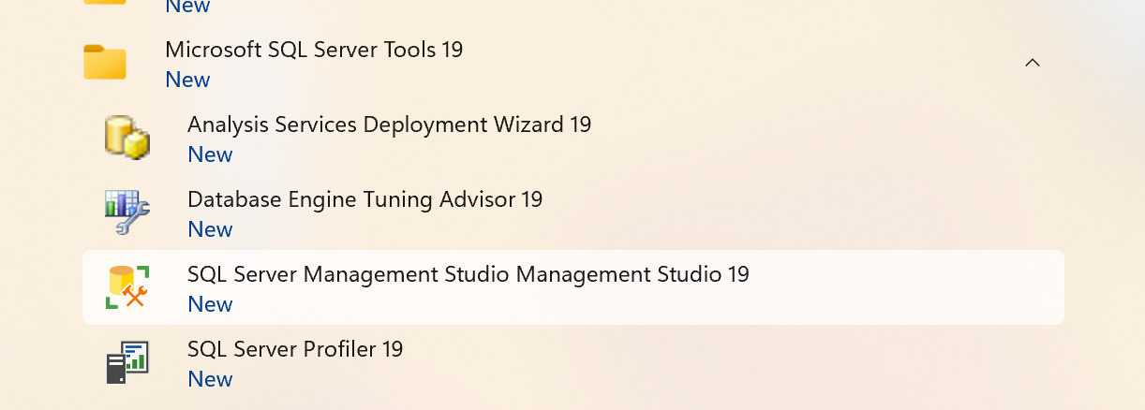

Step:2—connect

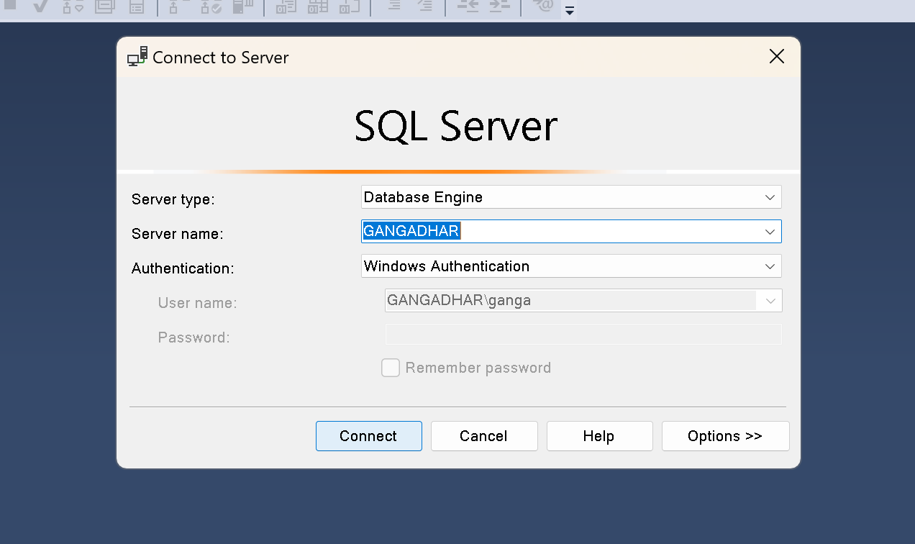

Step 3: once it connected the interface will be like below

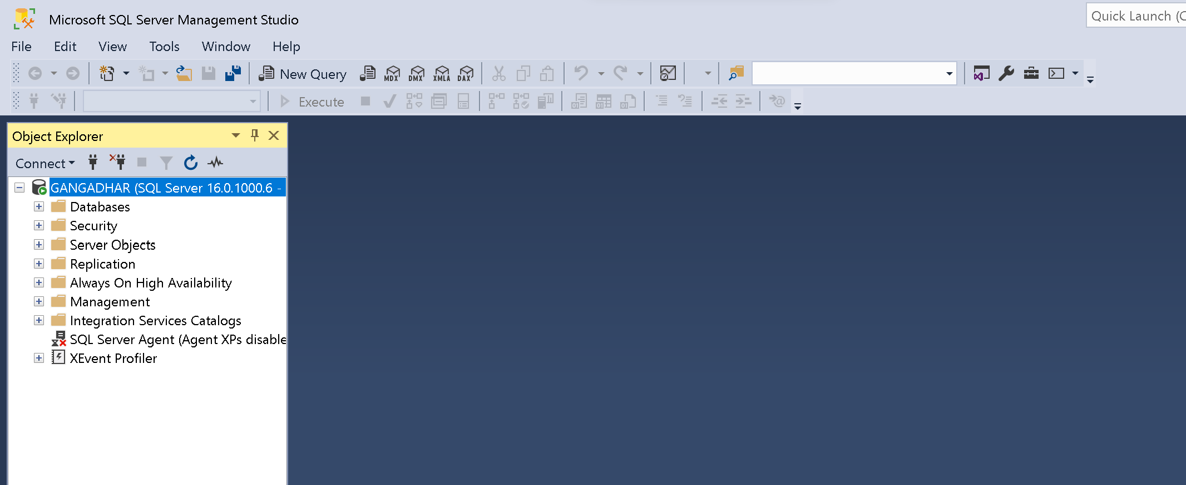

Step 4: click New Query to create database and table

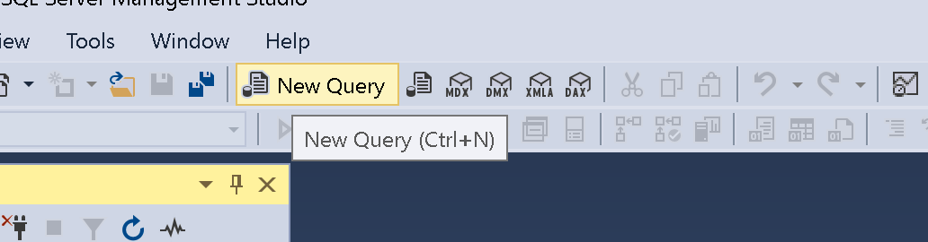

Step 5: once you click the New Query, below is the interface to execute the commands

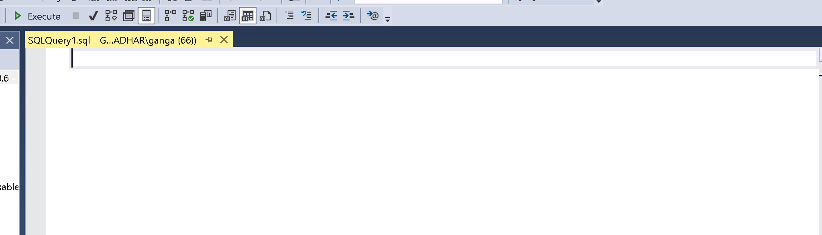

Step 6: execute the created command after selection

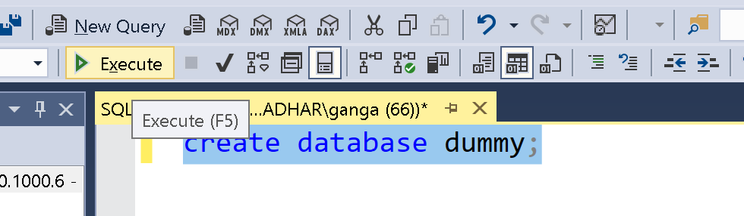

**Steps to create database, table, and add csv file to respective table**

* Create database by using following command

CREATE DATABASE database_name;

* Execute the command by selecting “CREATE DATABASE database_name;”
* Refresh the Database, it shows created database.
* To drop the database, write command “DROP DATABASE database_name
* Use database-----enter “USE database_name”
* Create table:

“CREATE TABLE table_name(coumn_1 datatype, column_2 datatype, …………);”

* Execute the command.
* To display the created data table, use below command

“SELECT * FROM table_name”

Sample scenario:

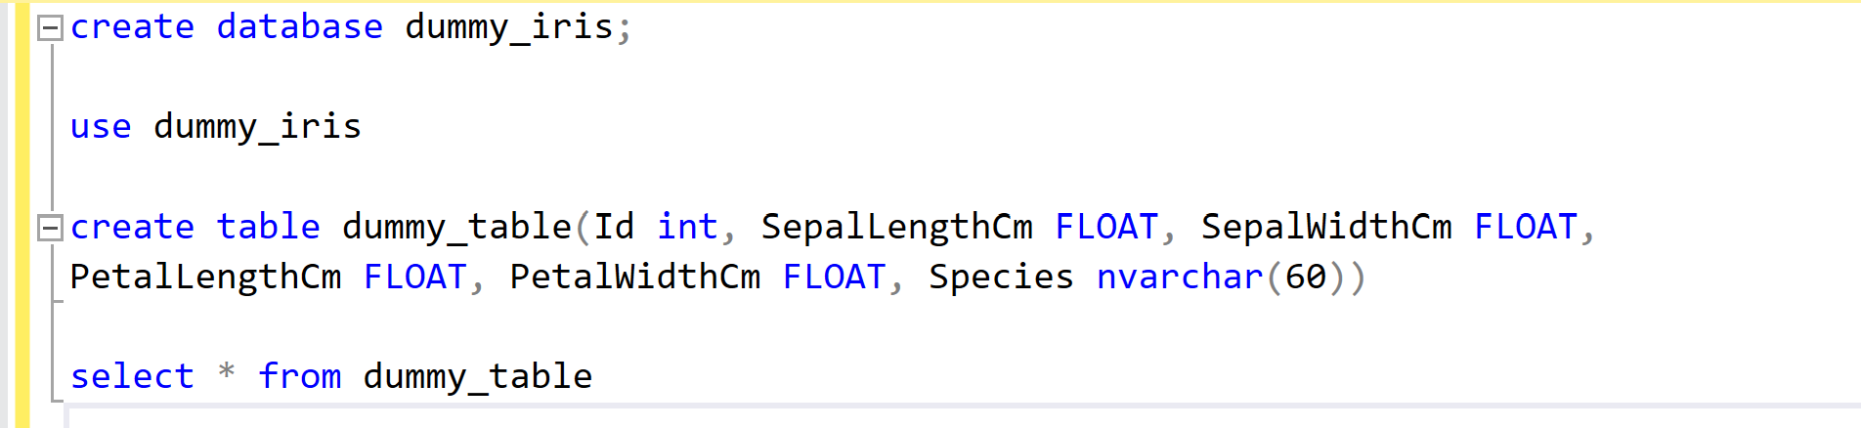

* Now upload to upload the csv dataset use below command

“USE database_name”

BULK INSERT table_name from 'csv file path'

WITH (FORMAT = 'CSV', FIRSTROW = 2, FIELDTERMINATOR = ',', ROWTERMINATOR = '0x0a',

KEEPNULLS);

Go

* In this case, 0x0a represents the newline character
* FIRSTROW = 2, represents data starts from second row
* FIELDTERMINATOR, specifies the character or string that separates individual fields or columns within each row of the CSV file being imported.
* KEEPNULLS, Keep NULL values in the imported data.

Sample code:

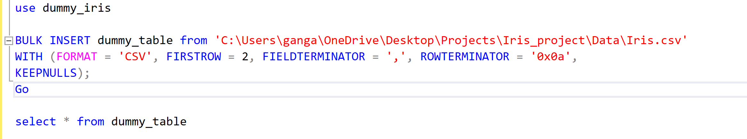

**END**